**Design Process**

Huanxin is responsible for the data transmission, Samuel takes the task to deal with the signal processing, while Leping is responsible for the main part and the last part of the whole project, which is controlling the GUI and make the data shown in users interface through the form of the electrical signals. Here are the works we did and the timeline in the project.

|  |  |  |  |  |
| --- | --- | --- | --- | --- |
| **Tasks** | **Due Date** | **Week/Day** | **Who?** | **Status** |
| First meeting and task allocation | 18/9/2022 | Week 7 Sun | Everyone | Completed |
| Explaining our separate signal processing techniques | 18/9/2022 | Week 7 Sun | Everyone | Completed |
| Bluetooth re-connection function in project | 21/9/2022 | Week 8 Wed | Leping | Completed |
| Completing basic functions and heart rate display on GUI | 25/9/2022 | Week 8 Sun | Leping | Completed |
| Doing moving averages filter | 25/9/2022 | Week 8 Sun | Samuel | Completed |
| Finishing data transmission | 3/10/2022 | Week 9 Mon | Huanxin | Completed |
| Supplying the log information on GUI as well as corresponding calling | 5/10/2022 | Week 9 Wed | Leping | Completed |
| Finishing the FFT work | 5/10/2022 | Week 9 Wed | Samuel | Completed |
| Switch testing on the board | 9/10/2022 | Week 9 Sun | Huanxin | Not finished |
| Selecting threshold of heart rate warning | 9/10/2022 | Week 9 Sun | Huanxin/Leping | Completed |
| Detecting the adaptive threshold | 9/10/2022 | Week 9 Sun | Samuel | Completed |
| Doing calculations on optimal resolution for FFT | 14/10/2022 | Week 10 Fri | Leping | Completed |
| Sending data packet and char list to Python | 14/10/2022 | Week 10 Fri | Huanxin | Completed |
| Second Meeting and progress checking as well as partly testing | 16/10/2022 | Week 10 Sun | Everyone | Completed |
| Modifying log recording in each second | 19/10/2022 | Week 11 Wed | Leping | Completed |
| Calculating the heart rate variability | 23/10/2022 | Week 11 Sun | Samuel | Not finished |
| Testing sequence number in Python | 23/10/2022 | Week 11 Sun | Huanxin | Completed |
| Third meeting and general testing of the whole system | 23/10/2022 | Week 11 Sun | Everyone | Completed |
| Project demonstration in Lab | 26/10/2022 | Week 12 Wed | Everyone | Completed |

Table 1. Timeline of Project

**Checkpoint Milestones**

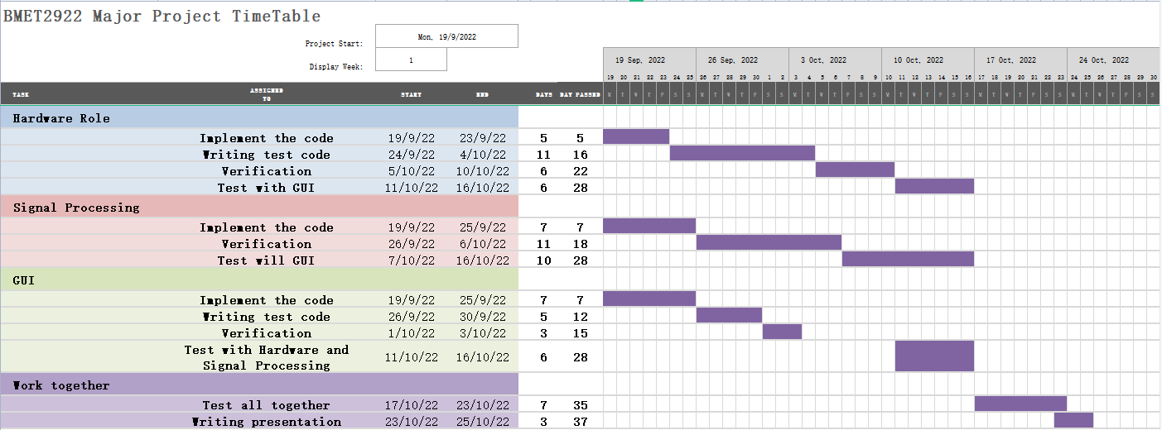

Fig1. Gantt Chart of Checkpoint

This is the Gantt Chart that we have did some revisions on it, the original project process did not succeed in our plan, the tasks in GUI were almost done in the ideal duration, but the duration in tasks of Hardware and Signal all got longer especially the writing test code section and verification section, as we got stuck in some problems in the project for some days, we also put some extra functions in the program, such as the “Log” function, moving average and so on, switch testing is another extra task that we did in the project, these are the reasons why we extend our duration in some parts.

**Testing Explanation**

There are a few testings that we did during the process of the whole project. The first testing we conducted is “selection” testing, it is used for checking whether the length of integer list is 3 or not, as it is important and should correct, and then we also have to check the output of the function. “Slider” testing is another one that we have to check the output, the ideal result of the code should be able to judge if the current heart rate is in the normal range, if it is abnormal, the warning should be output. We also conducted the “Transmission” testing during the project, of which the process is that we press the “en” button on the board, and see if there is any warning triggered after 5 seconds, actually it is similar with “Slider” test, they are both used to test whether the system can send out warnings in case of abnormal data. In addition, we also did the “Log” testing , Log function is mainly focused on checking whether the content and time of output is correct, the content and time are all associated with Log. Besides, there is also “Moving averages” function in the project, it briefly checks the output of any data that we input, for instance, we made the char list in Arduino, of which the length is 1000 as it consists of sequence number, sensor readings and so on, and there are 50 samples of heart rate readings, so the final data shown in Python should be the sequence numbers with their corresponding readings.

**Introduction and Background**

A noninvasive optical technique called photoplethysmography (PPG) has been employed in a wide variety of studies on the blood volume in a peripheral vascular bed [1]. Blood pressure readings, glucose measurements, and Heart Rate Variability (HRV) can all be measured with PPG [2]. Clinicians can also use this technology to measure respiratory rate and blood oxygen saturation [3]. A reliable indicator for the diagnosis of hypertension is the HRV and blood pressure [4]. Important markers of a patient's respiratory system function are blood oxygen saturation and respiratory rate. Overall, when these numbers are abnormal, the patient typically has a health issue. The market for wearable sensors, which the PPG technology can be utilized for, is growing and is expected to reach $5.8 billion in the USA in 2018 [5]. In order to get good transmittance, PPG probes are typically placed on such small extremities. However, new applications for PPG are now being used on the esophagus, the ankle, and various organs[6].

Visible light and low-intensity infrared radiation can pass through human tissue in some cases, allowing light to pass through the skin and be reflected, absorbed, and scattered in the tissue [1]. PPG's fundamental operating principle and mechanism is based on recording light absorptivity during the systole and diastole phases of heartbeat [6]. As the blood volume in the tissue increases during systole, the rate at which light is absorbed also rises. The sensor can detect this change to track the occurrence and progression of systole [6]. Properties such as the absorption of two specific wavelengths by oxyhemoglobin and deoxyhemoglobin are used to measure blood oxygen saturation (SpO2) [6]. The optical absorbance between systole and diastole causes AC and DC PPG signals, which can be utilized to estimate SpO2 [6]. An optical sensor with an emitter and detector, as well as a processor with signal processing features including filters and amplifiers, are common components of PPG devices [7].

When determining the HRV signal and pulse rate, PPG is a substitute for the ECG [8]. PPG only needs one wire to link the infrared emitter and detector, which is advantageous for ambulatory use compared to ECG, which needs three cables to connect three electrodes to the patients [2]. PPG is additionally simpler to use, more comfortable to wear, and more cost-effective [2]. Additionally, several biological parameters can be obtained with a single PPG probe [9]. The PPG signal is susceptible to a variety of disturbances, including motion artifacts brought on by motions and background noise [2]. While electrical artifacts can easily affect the ECG signal [9], The fact that the change in blood volume has a phase delay compared to the ECG signal, which depends on the flexibility of blood vessels, is a significant drawback for PPG [9] The capacity to measure the temporal dynamics of a small number of heartbeats will decline as a result of this delay [9]. The PPG signal is thought to be less accurate than the ECG signal, which is another drawback [10].

**References**

1. P. A. Kyriacou, “1 - introduction to photoplethysmography,” in Photoplethysmography, J. Allen and P. Kyriacou, Eds. Academic Press, 2022, pp. 1–16.

[2] D. Castaneda, A. Esparza, M. Ghamari, C. Soltanpur, and H. Nazeran, “A review on wearable photoplethysmography sensors and their potential future applications in health care,” Int. J. Biosens. Bioelectron., vol. 4, no. 4, pp. 195–202, Aug. 2018.

1. A. A. Alian and K. H. Shelley, “10 - ppg in clinical monitoring,” in Photoplethysmography, J. Allen and P. Kyriacou, Eds. Academic Press, 2022, pp. 341–359.

[4] E. B. Schroeder, D. Liao, L. E. Chambless, R. J. Prineas, G. W. Evans, and G. Heiss, “Hypertension, blood pressure, and heart rate variability,” Hypertension, vol. 42, no. 6, pp. 1106–1111, 2003.

[5] J. Wei, “How wearables intersect with the cloud and the internet of things: Considerations for the developers of wearables.” IEEE Consumer Electronics Magazine, vol. 3, no. 3, pp. 53–56, 2014.

1. P. A. Kyriacou and S. Chatterjee, “2 - the origin of photoplethysmography,” in Photoplethysmography, J. Allen and P. Kyriacou, Eds. Academic Press, 2022, pp. 17–43.

[7] K. Budidha and P. A. Kyriacou, “3 - photoplethysmography technology,” in Photoplethysmography, J. Allen and P. Kyriacou, Eds. Academic Press, 2022, pp. 43–68.

[8] V. Jeyhani, S. Mahdiani, M. Peltokangas, and A. Vehkaoja, “Comparison of HRV parameters derived from photoplethysmography and electrocardiography signals,” Annu Int Conf IEEE Eng Med Biol Soc, vol. 2015, pp. 5952–5955, 2015.

[9] G. Lu, F. Yang, J. A. Taylor, and J. F. Stein, “A comparison of photoplethysmography and ECG recording to analyse heart rate variability in healthy subjects,” J. Med. Eng. Technol., vol. 33, no. 8, pp. 634–641, 2009.

[10] H.-Y. Jan, M.-F. Chen, T.-C. Fu, W.-C. Lin, C.-L. Tsai, and K.- P. Lin, “Evaluation of coherence between ecg and ppg derived parameters on heart rate variability and respiration in healthy volunteers with/without controlled breathing,” Journal of Medical and Biological Engineering, vol. 39, no. 5, pp. 783–795, Oct 2019.

**Group Member Contribution**

Huanxin is responsible for the part of hardware and data transmission in the project. Firstly he checked the system in Arduino with the correct board and port in order to run the code on it and make host computer can work normally with micro controller. Then he just built a few functions such as “SerialBT.printf” that used for sending data packet as well as a char list in Arduino, of which the length is 1000, because the format of the reading consists of sequence number, one space, heart rate as well as the sensor readings, and there are 50 samples, so he just made it as long as possible, then he sent it to Python and turn it to a normal list. In Python there are the codes that play the role of testing and verifying the sequence number:

*if started and cur_sequence != last_sequence + 1:*

*transmission_stable_sequence = False*

*else:*

*transmission_stable_sequence = True*

It is used to determine whether the current sequence number is 1 bigger than last one, as the sequence number with the corresponding reading is very important. During the project, Huanxin also took the duty of recording every meeting’s content and some important discussion during it, so he just collected the information of everybody’s work from the feedback in each meeting, which helps him make the timeline of our status of tasks and sort out the process of the whole project designing. For report writing, he is also responsible for writing introduction, he just compared the reports written by the three of us, and selected the excellence of their contents for consolidation, combined his own ideas on PPG technology. The above is his contribution to the team.